Hello everyone,

I hope this finds everyone well and looking forward to February and preparation for Lent.

Please find below information about upcoming offerings at St. Simeon’s.

We look forward to seeing as many as possible at these events.

Sincerely,

Edna

1. A video series about the Beatitudes is now being posted on our YouTube channel (St. Simeon’s Church) one week at a time for 9 weeks.

A link can be found on our website **https//stsimeonsanglican.ca** and on our Facebook page

**St. Simeon’s Family Service.**

Our thanks to Gordon and Rolanda McPhee.

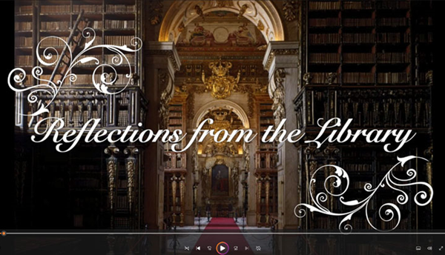

2. A Lenten Bible Study will begin on

Wednesday, February 14, 2024

at 10:30 am

in the Common Room of the Rotary Apartments

Jesus Our Light and Our Life

Becoming One in Christ



Throughout the study we will read about

the Samaritan woman, the man born blind,

Lazarus and Mary and Martha.

Consider journeying with us as we read and discuss

these stories of Christian transformation.

3. St. Simeon’s Ash Wednesday Service

February 14

at 12 Noon

Led by Rev’d Nick.

4. Annual Vestry Meeting

February 25

following Morning Worship.