Page from an anniversary supplement of The Lachute Watchman dated Wednesday, June 29, 1977
Sent to me by Vicki Milnes in May, 2023

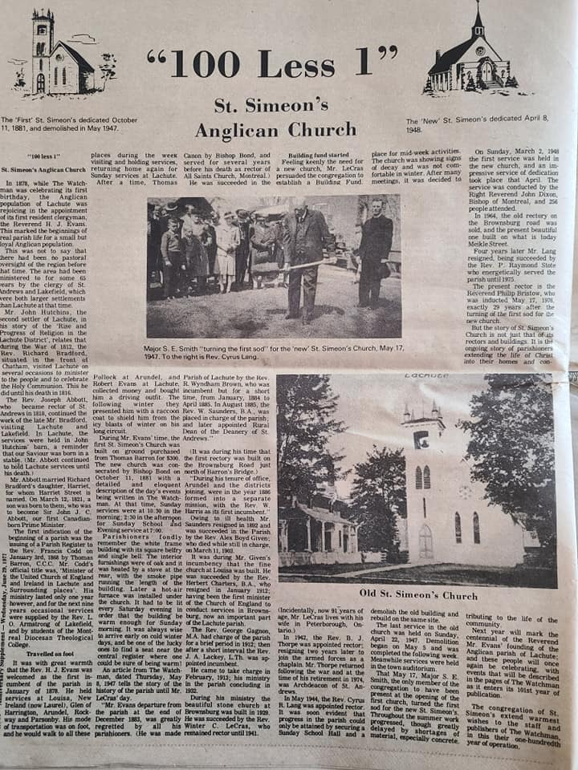

Transcript of the article

“100 Less 1”
St. Simeon’s Anglican Church

In 1878 while the Watchman was celebrating its first birthday, the Anglican population of Lachute was rejoicing in the appointment of its first resident clergyman, the Reverend H. J. Evans. This marked the beginnings of real parish life for a small but loyal Anglican population.

This was not to say that there had been no pastoral oversight of the region before that time. The area had been ministered in for some 65 years by the clergy of St. Andrews and Lakefield, which were both larger settlements than Lachute at that time.

Mr. John Hutchins, the second settler of Lachute, in his story of the “Rise and Progress of Religion in the Lachute District”, relates that during the War of 1812, the Rev. Richard Bradford, situated in the front of Chatham, visited Lachute on several occasions to minister to the people and to celebrate the Holy Communion. This he did until his death in 1816.

The Rev. Joseph Abbott, who became rector of St. Andrews in 1818 continued the work of Mr. Bradford, visiting Lachute and Lakefield. In Lachute, the services were held in John Hutchin’s barn, a reminder that our Saviour was born in a stable. (Mr. Abbott continued to hold Lachute services until his death.)

Mr. Abbott married Richard Bradford’s daughter, Harriet, for whom Harriet street is named. On March 12, 1821, a son was born to them, who was to become Sir J. C. Abbott, our first Canadian born Prime Minister.

The first indication off the beginning of a parish was the issuing of a Parish Register to the Rev. Francis Codd on January 3rd, 1868 by Thomas Barron, C.C.C. Mr. Codd’s official title was “Minister of the United Church of England and Ireland in Lachute and surrounding places”. His ministry lasted only one year however, and for the next nine years occasional services were supplied by the Rev. L.O. Armstrong of Lakefield, and by students of the Montreal Diocesan Theological College.

Travelled on foot

It was with great warmth that the Rev. H.J. Evans was welcomed as the first incumbent of the parish in January of 1878. He held services at Louisa, New Ireland ( now Laurel), Glen of Harrington, Arundel, Rockway and Parsonby. His mode of transportation was on foot, and he would walk to all these places during the week visiting and holding services, returning home again for Sunday services at Lachute.

After a time, Thomas Pollock at Arundel and Robert Evans at Lachute, collected money and bought him a driving outfit. The following winter they presented him with a raccoon coat to shield him from the icy blasts of winter on his long circuit.

During Mr. Evans’ time, the first St. Simeon’s Church was built on ground purchased from Thomas Barron for $300. The new church was consecrated by Bishop Bond on October 11, 1881 with a detailed and eloquent description of the day’s events being written in The Watchman. At that time, Sunday services were at 10:30 in the morning, 2:30 in the afternoon for Sunday School and Evening services at 7:00.

Parishioners fondly remember the white frame building with its square belfry and single bell. The interior furnishings were of oak, and it was heated by a stove at the rear, with the smoke pipe running the length of the building. Later, a hot air furnace was installed under the church. It had to be lit every Saturday evening in order that the building be warm enough for Sunday morning. It was always wise to arrive early on cold winter days and be one of the lucky ones to find a seat near the central register where one could be sure of being warm!

An article from The Watchman, dated Thursday, May 8, 1947 tells the story of the history of the parish until Mr. LeCras’ day.

“Mr. Evans departure from the parish at the end of December 1863, was greatly regretted by all his parishioners. (He was made Canon by Bishop Bond and served for several years before his death as rector of All Saints Church, Montreal)
He was succeeded in the Parish of Lachute by the Rev. R. Wyndham Brown who was incumbent but for a short time from January 1884 to April 1885. In August 1885, the Rev. W. Saunders, B.A. was placed in charge of the parish and later appointed Rural Dean of the Deanery of St. Andrews.”

(It was during his time that the first rectory was built on the Brownsburg Road just north of Barron’s Bridge.)

“During his tenure of office, Arundel and the districts joining, were in the year 1886 formed into a separate mission with the Rev. W. Harris as its first incumbent.”

Owing to ill health, Mr. Saunders resigned in 1892 and was succeeded in the parish by the Rev. Alen Boyd Given who died while still in charge on March 11, 1903.

It was during Mr. Given’s incumbency that the fine church at Louisa was built. He was succeeded by the Rev. Hebert Charters, B.A. who resigned in January 1912, having been the first minister of the Church of England to conduct services in Brownsburg, now an important part of the Lachute parish.

The Rev. George Gagnon, M.A. had charge of the parish for a brief period 1912; then after a short interval the Rev. J.A. Lackey, L.Th. was appointed incumbent.

He came to take charge in February 1913, his ministry in the parish concluded in 1932.

During his ministry, the beautiful stone church at Brownsburg was built in 1929. He was succeeded by the Rev. Winter C. LeCras who remained rector until 1941.

Building fund started

Feeling keenly the need for a new church, Mr. LeCras persuaded the congregation to establish a Building Fund.
(Incidentally, now 91 years of age, Mr. LeCras lives with his wife in Peterborough, Ontario.)

In 1942 the Rev. B.J. Thorpe was appointed rector resigning 2 years later to join the armed forces as a chaplain. Mr, Thorpe returned following the war at the time of his retirement in 1974, he was Archdeacon of St. Andrews.

In May, 1944, the Rev. Cyrus R. Lang was appointed rector. It was soon evident that progress in the parish could only be attained by securing a Sunday School Hall and a place for midweek activities. The church was showing signs of decay and was uncomfortable in winter. After many meetings, it was decided to demolish the old building and rebuild on the same site.

The last service in the old church was held on Sunday, April 22, 1947. Demolition began on May 5 and was completed the following week. Meanwhile services were held in the town auditorium.

That May 17, Major S.E. Smith, the only member of the congregation to have been present at the opening of the first church, turned the first sod for the new St. Simeon’s. Throughout the summer work progressed, though greatly delayed by the shortages of material, specifically, concrete.

On Sunday, March 2, 1948, the first service was held in the new church, and an impressive service of dedication took place that April. The service was conducted by the Right Reverend John Dixon, Bishop of Montreal, and 254 people attended.

In 1964, the old rectory on the Brownsburg Road was sold, and the present beautiful one built on what is today Meikle Street.

Four years later, Mr. Lang resigned, being succeeded by the Rev. P. Raymond Stote who energetically served the parish until 1975.

The present rector is the Reverend Philip Bristow who was inducted May 17, 1975, exactly 29 years after the turning of the first sod for the new church.

The story of St. Simeon’s Church is not just that of its rectors and buildings. It is the ongoing story of parishioners extending the life of Christ into their homes and contributing to the life of the community.

Next year will mark the centennial of the Rev. Mr. Evans’ founding of the Anglican parish of Lachute and these people will once again be celebrating with events that will be described in the pages of The Watchman as it enters its 101st year of publication.

The congregation of St. Simeon’s extend warmest wishes to the staff and publisher of The Watchman in this their one-hundredth year of operation.

